Email Security Framework for Corporate Communication Using S/MIME and Spam Detection

CSA5193-Cryptography and Network Security for Secure System Design

SUBMITTED TO

# SAVEETHA INSTITUTE OF MEDICAL AND TECHNICAL SCIENCES

In partial fulfilment of the award of the degree of

# BACHELOR OF ENGINEERING IN COMPUTER SCIENCE BY

# SRIRAAGAVI D.K [192210713]

# INBA PRANAOU I.V [192210726]

SUPERVISOR

ALPHONSA



**SAVEETHA SCHOOL OF ENGINEERING, SIMATS CHENNAI- 602105**

**January-2025**

**INDEX**

|  |  |  |
| --- | --- | --- |
| **S.NO** | **CONTENT** | **PAGE NO.** |
| **1** | ABSTRACT |  |
| **2** | INTRODUCTION |  |
| **4** | EXISTING TECHNOLOGY |  |
| **5** | PROPOSED TECHNOLOGY |  |
| **6** | FLOW DIAGRAM |  |
| **7** | OUTPUT |  |
| **8** | FUTURE ENHANCEMENT |  |
| **9** | CONCLUSION |  |

ABSTRACT:

In the age of rapid digital transformation, email remains a critical channel for corporate communication. However, it is increasingly threatened by cyberattacks such as phishing, spoofing, and spam, compromising the confidentiality, integrity, and availability of sensitive information. This paper presents a robust email security framework designed to protect corporate communications by integrating Secure/Multipurpose Internet Mail Extensions (S/MIME) with advanced spam detection techniques. The framework leverages S/MIME to ensure end-to-end encryption, digital signatures, and content authenticity for email communications, preventing unauthorized access and message tampering. Additionally, an intelligent spam detection system is incorporated using machine learning algorithms to filter and block unsolicited and malicious emails. By analyzing patterns and identifying spam characteristics, the system enhances the reliability and accuracy of email filtering, minimizing false positives and negatives. The experimental results demonstrate the effectiveness of the proposed system in mitigating email-based threats, improving communication security, and fostering trust among corporate stakeholders. This study aims to provide a practical solution for enterprises seeking to fortify their email security infrastructure while promoting a secure and efficient communication ecosystem.

INTRODUCTION

Email remains one of the most widely used and critical modes of communication in corporate environments, facilitating seamless interaction among employees, clients, and stakeholders. However, as email usage grows, it has become a primary target for cyberattacks, including phishing, spoofing, spam, and malware distribution. These threats pose significant risks to the confidentiality, integrity, and availability of corporate data, resulting in financial losses, reputational damage, and operational disruptions. Thus, the need for a robust and reliable email security framework is more pressing than ever. Traditional email security solutions often rely on isolated mechanisms, such as basic spam filters or encryption tools. While these measures provide a degree of protection, they are often insufficient against sophisticated attacks. To address this gap, the proposed framework integrates Secure/Multipurpose Internet Mail Extensions (S/MIME) and advanced spam detection technologies to deliver comprehensive email security.

S/MIME, a widely accepted standard for email encryption and digital signatures, ensures the confidentiality and authenticity of email messages. By encrypting the content and attaching a digital signature, S/MIME provides end-to-end protection, preventing unauthorized access and tampering during transmission. However, S/MIME alone does not address the issue of spam or malicious emails, which can bypass traditional security layers. To complement S/MIME, the proposed framework incorporates an intelligent spam detection system powered by machine learning algorithms. By analyzing email metadata, content, and behavioral patterns, the system effectively identifies and filters spam emails, minimizing risks posed by phishing attempts and malware-laden messages

This framework also emphasizes scalability and ease of integration, enabling enterprises to adopt it without disrupting existing workflows. The proposed system is designed to comply with regulatory requirements and industry best practices, ensuring that organizations meet legal obligations while enhancing their security posture.This paper outlines the development and implementation of the email security framework, evaluates its performance through empirical analysis, and demonstrates its ability to counteract email-based threats effectively. By adopting this framework, organizations can significantly enhance the security, reliability, and efficiency of their corporate communication systems.

EXISTING TECHNOLOGY

Email security has been an area of continuous evolution as organizations attempt to combat an ever-increasing array of cyber threats. Various technologies and tools have been developed to address specific aspects of email security, ranging from encryption protocols to spam detection systems. However, these existing solutions often function in isolation, leaving gaps in comprehensive protection. One of the most widely used technologies in email security is encryption, which protects the content of messages from unauthorized access. Secure/Multipurpose Internet Mail Extensions (S/MIME) and Pretty Good Privacy (PGP) are the two primary standards. S/MIME provides encryption and digital signature capabilities, ensuring the confidentiality and authenticity of email messages. While S/MIME is effective in safeguarding email content, it does not address threats like spam or phishing emails. Additionally, implementing S/MIME in corporate environments can be complex due to the requirement for certificate management.

**Spam Detection Systems**

Spam detection tools aim to filter unsolicited and potentially harmful emails. Traditional methods use rule-based filters that rely on predefined heuristics to identify spam. Modern approaches leverage machine learning algorithms, such as Naïve Bayes, Support Vector Machines (SVM), and deep learning models, to classify emails based on features like content, sender behavior, and metadata. While these systems have improved accuracy, they may still generate false positives or negatives, leading to operational inefficiencies. Moreover, they are limited in addressing encrypted email threats or ensuring message authenticity.

PROPOSED TECHNOLOGY

To address the limitations of existing email security solutions, this paper introduces a comprehensive email security framework that combines the strengths of **Secure/Multipurpose Internet Mail Extensions (S/MIME)** for encryption and authentication with advanced **machine learning-based spam detection**. The proposed framework provides a unified solution to safeguard corporate communications from unauthorized access, message tampering, and spam-based cyberattacks.

**Key Components of the Framework**

1. **S/MIME for Encryption and Authentication**
   * **End-to-End Encryption**: S/MIME is utilized to encrypt email messages, ensuring that only intended recipients can access the content. This protects sensitive corporate information from being intercepted or leaked during transmission.
2. **Machine Learning-Based Spam Detection**
   * **Dynamic Filtering**: A machine learning model trained on large datasets of email metadata, content, and sender behavior is integrated to identify spam and phishing emails effectively. This model continuously adapts to evolving threats by leveraging real-time feedback and retraining.

**Integration and Scalability**

The proposed framework is designed for seamless integration into existing corporate email systems, such as Microsoft Exchange or Google Workspace. It employs lightweight APIs and plugins to minimize disruption during deployment. Additionally, the system supports scalability for large enterprises, handling high volumes of email traffic without significant latency.

**Advantages of the Proposed Framework**

* **Comprehensive Security**: By combining encryption, authentication, and spam detection, the framework ensures end-to-end protection against a wide range of email threats.
* **Enhanced Usability**: Automated certificate management and intuitive user interfaces simplify adoption for both IT administrators and employees.
* **Real-Time Adaptability**: The machine learning model’s ability to learn from new patterns and adjust to emerging threats ensures that the framework remains effective over time.
* **Regulatory Compliance**: The system adheres to industry standards such as GDPR, HIPAA, and other compliance requirements, making it suitable for organizations across different sectors.

This integrated framework provides a robust and scalable solution to modern email security challenges, empowering organizations to protect their communications, safeguard sensitive data, and maintain trust within their networks.

FLOW DIAGRAM

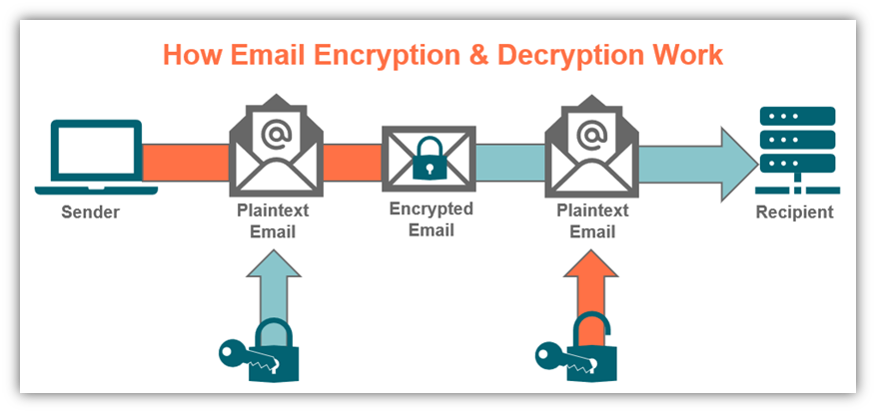

OUTPUT

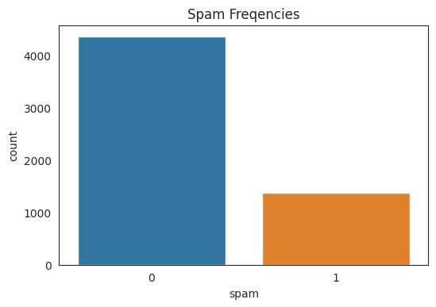

FUTURE ENHANCEMENT

Future enhancements for the proposed email security framework focus on incorporating advanced technologies and expanding its capabilities to address evolving threats. Integrating AI-powered threat intelligence can enable real-time identification and mitigation of new attack patterns and zero-day vulnerabilities. The use of blockchain technology for certificate management can enhance the security and transparency of the encryption process, minimizing risks associated with certificate misuse.Expanding the system to include sophisticated behavioral analytics can help detect anomalies in user activity, such as unusual login locations or sending patterns, which might indicate compromised accounts. Additionally, enhancing compatibility with mobile devices and various platforms ensures seamless security across all user interfaces. Combining the framework with multi-factor authentication (MFA) provides an extra layer of security, making it harder for unauthorized users to access sensitive communications. Lastly, embedding user training modules within the system can improve awareness about phishing and other threats, fostering a culture of cybersecurity within organizations.

CONCLUSION

The proposed email security framework effectively addresses the challenges of corporate communication by integrating **Secure/Multipurpose Internet Mail Extensions (S/MIME)** with advanced **spam detection mechanisms**. S/MIME ensures end-to-end encryption and authentication, safeguarding the confidentiality and integrity of email messages, while the machine learning-based spam detection system filters out malicious and unsolicited emails. This unified approach ensures robust protection against a wide range of email threats, including phishing, spoofing, and spam, while maintaining scalability, usability, and compliance with regulatory standards. The system’s adaptability to emerging threats and its ease of integration into existing corporate email infrastructures make it a valuable asset for enterprises of all sizes. Future enhancements, such as AI-driven threat intelligence, advanced behavioral analytics, and mobile compatibility, can further strengthen the framework, ensuring it remains effective in an ever-evolving threat landscape.